Module 3: Key Support Functions for Insurer Success 1
Lesson 1: Marketing 1
Learning Objectives 1
Marketing and the Marketing Mix 2
Target Marketing 20
Marketing Information 32

Module 3: Key Support Functions for Insurer Success
Some functions primarily provide support to other functions. In this module, we’ll discuss three of the most important support functions that are essential to an insurance company’s success.
In this module, you’ll learn about
- How insurers use research and data to develop their marketing mix
- The process insurers use to create successful new products
- How the legal and compliance functions work together and separately to keep the insurer on the right side of the law

Lesson 1: Marketing
Marketing is so much more than advertising. It’s a research-driven discipline designed to help a company get the right products to the right customers at the right place through the right distribution systems. Learn how insurers carry out the various aspects of the marketing discipline.

Learning Objectives

- Identify and describe the elements of a marketing plan.
- Identify and describe the four variables that make up the traditional marketing mix and the newer "Four Cs" model.
- Distinguish among three promotional tools insurers use to help them convey their messages to customers.
- Describe how insurers use market segmentation and target marketing to identify the customers most likely to benefit from their products.
- Distinguish among three primary types of target marketing strategies.
- Describe different sources that insurers use for obtaining market information.
- Identify elements in the internal and external marketing environments.
- Describe marketing controls.
- Explain the duties of the marketing department and what other functional areas contribute to marketing activities.

Marketing and the Marketing Mix
Learning Objective
Identify and describe the elements of a marketing plan.
Identify and describe the four variables that make up the traditional marketing mix and the newer "Four Cs" model.
Our new business results have not been living up to projections lately. We've got to revisit our marketing strategy.

Start

Forthright targets the affluent market with individual life insurance and annuities. Because these products are complex, we rely on personal selling. Our financial professionals need to be able to explain our products clearly and simply or else the customers simply won't buy them.
Customers choose Forthright for our great service, trustworthiness, and financial strength. So, we emphasize image advertising—campaigns to enhance our overall image. And our corporate communications department makes sure that the press coverage of Forthright is as positive as possible.
Another key here is in a product's financial design. Some customers want a fast accumulation of cash value. Others want to be able to withdraw their money from the start with no penalty. Customers want options. And if we add high fees and charges to our products, customers are going to get turned off. These factors are all part of marketing here at Forthright.
Wait....What does all that have to do with marketing?

You might think marketing is just advertising, but there's more to it than that. You might think marketing is just selling, but it's more than just that, too. Here's a definition.
"Marketing is the activity, set of institutions, and processes for creating, communicating, delivering, and exchanging offerings that have value for customers, clients, partners, and society at large."
American Marketing Association, 2007.
Let's look more closely at the elements of marketing.
The Marketing Plan
First, the marketing department must develop a marketing plan, which is a written document that states the marketing goals for a product or product line. Marketing plans vary among companies, but typically contain
- An executive summary, or a brief highlight of the purpose, recommendations, costs, and intended results
- A situation analysis, or an explanation of the environmental factors affecting marketing operations
- Marketing objectives
- Marketing strategies
- Tactical/action programs, or a description of the activities to be carried out
- Budgets
- The evaluation methodology, or the controls the company will use to analyze progress toward goals
The marketing plan should be communicated to everyone involved in carrying out the marketing strategy.
The Marketing Mix
To market effectively, marketing departments need to understand the details of
- Product
- Price
- Promotion
- Distribution
These four variables work together to attract customers, trigger buying, and help companies meet business goals.
Product
Let's start with product, which refers to the goods, services, or ideas that a seller offers to customers to satisfy a need. An individual company's objective is to provide products that meet the needs of its customers. Thus, the company markets a variety of products geared toward satisfying its customers' needs.
By now, you probably know the products the insurance industry offers: life insurance, annuities, retirement products, medical coverage, and disability insurance. Some companies (especially big ones) offer all of these products in several different flavors. But not all companies offer all of these. Some specialize in a few products, or even just one.
Here are some of the traditional life and health insurance product types a company might specialize in.
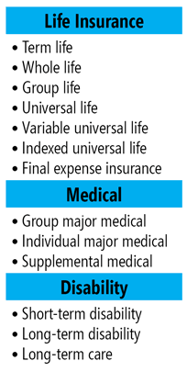
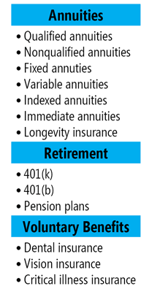
A company's product mix—the assortment of products a company offers—plays a big role in its marketing profile and its success. Product development, which we discuss in the next lesson, is a huge factor in determining the company's product offerings.
Product development is guided by the company's product strategy, which is formulated at the highest levels.
Financial Design
Now let's look at the next variable.
Although sometimes referred to as “price,” for insurance products, it's more useful to talk about financial design—which encompasses all the financial features of a product.

Which of these do you think are potential features of insurance product financial design? Choose all that apply.
- Required premium payments
- Mortality charges
- Charges for features, benefits, guarantees, etc.
- Fees for services, transactions, etc.
- Charges (if any) for early surrender or withdrawal
- How fast the cash value accumulates
- Investment or interest rate minimum guarantees
- Guaranteed income, accumulation, or withdrawal benefits
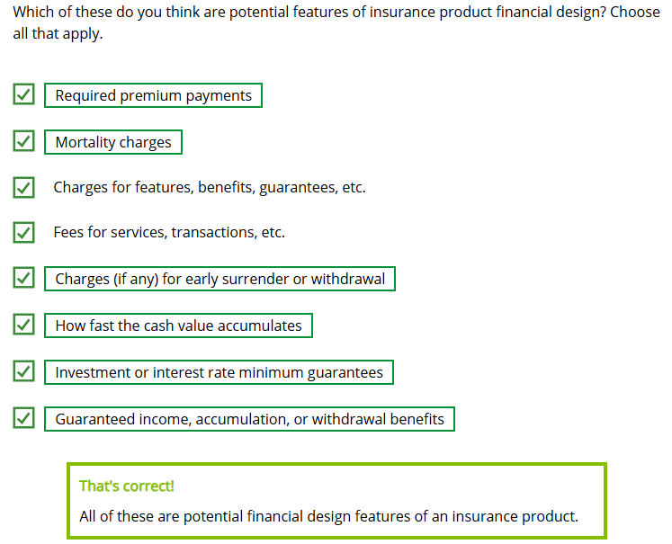
Different customers have different needs. Insurers can meet those needs with different financial designs, but, whether they are buying cookies, insurance, or an annuity, customers want to feel
- They are getting the best value available
- If they are paying more—such as a higher premium or extra charges for additional features—then what they are getting is worth the extra money
We'll learn more about financial design elsewhere in the course. For now, let's move on to the next variable.
Distribution
Let's think about cookies. You can buy them in several places: the supermarket, the bakery, or a café, for example. As a cookie manufacturer, you can choose the "place" where you will sell your cookies.

For insurance, we use the term "distribution" more often than "place," because the means of distributing insurance products does not necessarily correspond with a specific type of place, as it does with many products.
As you learned earlier in the course, some of the distribution methods insurers use that involve face-to-face meetings with the client include
- Career agents
- PPGAs
- Independent agents
- Broker/dealers
- Registered investment advisors (RIAs)
- Banks and other depository institutions
- Other insurance companies
- Employee benefits brokers
Insurers also use direct-to-consumer distribution methods, such as
- Email
- Company website
- Phone
- Mail
An insurer's distribution choices are an important part of its marketing mix.
Promotion
Promotion refers to the collection of activities that companies use to make customers aware of their offerings and to influence customers to purchase, and distributors to sell, a product. Insurers typically use three types of promotion.
First, personal selling involves conversation between a sales agent and one or more prospective customers, either face to face or over the phone. Insurers use personal selling extensively, because it is an effective way to convey information about a complex product. Why?
- The customer can ask questions to clarify information
- The financial professional can customize the message to fit the situation
Here's another type of promotion: advertising. I think we all know advertising when we see it, but could you define it?
Advertising is any paid form of nonpersonal communication or promotion about a company or its products or services that an identified sponsor generates and transmits through any type of media.
Insurers typically use advertising media such as television, radio, direct mail, the internet, social media, magazines, newspapers, billboards, and posters. Advertising media can reach a high number of people but in many cases is not customized for individuals. The internet can allow for some degree of customization, however (for example, based on previous purchases or demographic profile).
Institutional Advertising
One way insurers reach prospective customers is through institutional advertising, also called image advertising, which seeks to promote a general image of the company rather than to explain a specific product. For example, insurers may use institutional advertising to try to convey an image of strength, trust, reliability, longevity, or stability.
Product Advertising
Insurers also use product advertising to promote a specific product. Complex insurance products can be difficult to explain adequately in an advertisement. Product advertising can be aimed at financial professionals or the end customer.
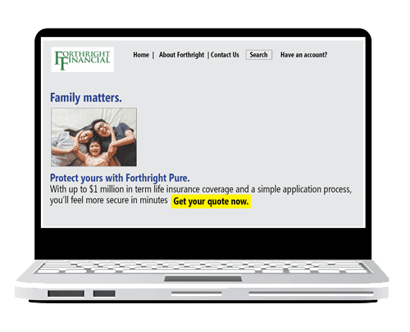
Let's look at our third type of promotion. Publicity is a form of nonpaid communication about a person, place, thing, or cause. For example, companies often provide news releases to the media. Publicity is economical (free, that is!), but the insurer has limited control over precisely what information the media chooses to transmit and in what way.
Another Marketing Mix Model: The Four Cs
Experts have long used the variables of product, price, promotion, and distribution to classify marketing activities. However, many marketers recently have started to use a new model called the “Four Cs” to describe the marketing mix. These marketers consider the Four Cs model to be more applicable to service industries and more customer centric. The Four Cs are (click or touch the right arrows to see them all)

Customer. The insurer analyzes who its customers are, what their needs are, and what products it can provide to meet those needs.
Marketing Mix Objectives
In all cases, the elements of the marketing mix need to (click or touch each heading to see more):
Fit together so that each one supports the others
The type of product a company offers determines the type of distribution methods the insurer uses. The type of distribution an insurer chooses for a product, in turn, helps determine the product's price.
Align with the company's overall strategic goals
If a company's strategic goal is to be an industry leader in sales of term life insurance, the marketing mix should include specific strategies for customer, cost, convenience, and communication that will allow the company to sell term life insurance policies to customers more successfully than its competitors can.
Support the company's positioning strategy
Through positioning, an insurer attempts to distinguish itself from other insurers in the marketplace by building a company image or product image that contrasts with the images competitors offer. An insurer may position itself on the basis of company or product attributes, types of products offered, price and quality of products, markets serviced, or distribution characteristics.
Support the company's branding strategy
Companies develop branding strategies to distinguish themselves among competitors. A company's brand—such as its name, slogan, and visual elements like a logo or color scheme—can draw customers to that company. To develop brand loyalty among customers, insurers need to create positive reactions to the brand by delivering positive customer experiences.

Insurers often substitute the term "financial design" for the marketing mix variable commonly known as
- Product
- Price
- Place
- Promotion
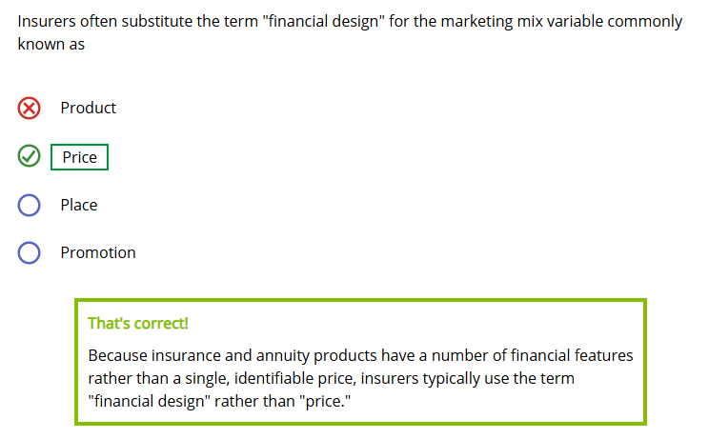
"Distribution" is a term commonly used in insurance for the marketing mix variable known as
- Product
- Price
- Place
- Promotion
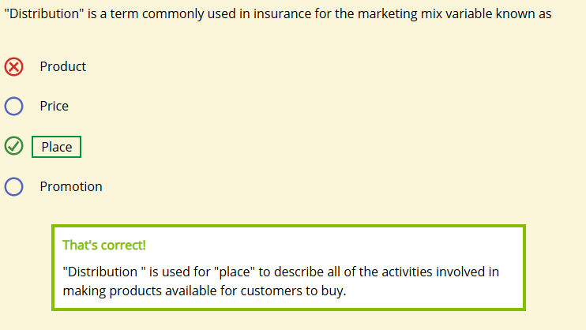
Select the type of promotion that matches each description.
A form of nonpaid communication about a person, place, thing, or cause.
- Advertising
- Publicity
- Personal selling
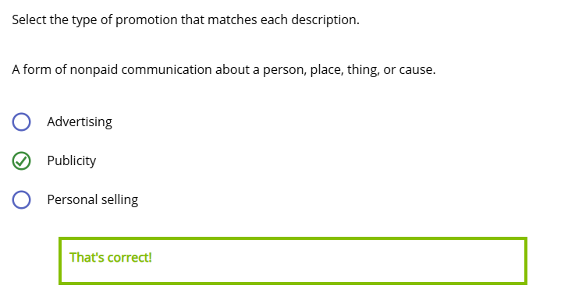
Nonpersonal communication or promotion about a company or its products or services that an identified sponsor generates and transmits through any type of media.
- Advertising
- Publicity
- Personal selling
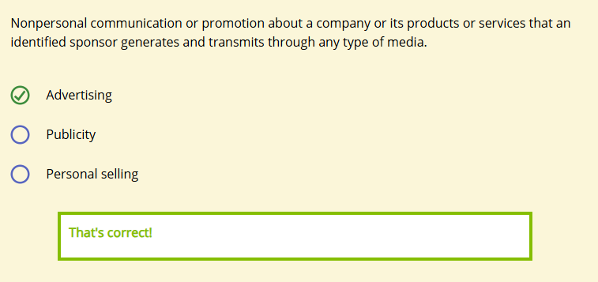
Conversation between a financial professional and one or more prospective customers.
- Advertising
- Publicity
- Personal selling
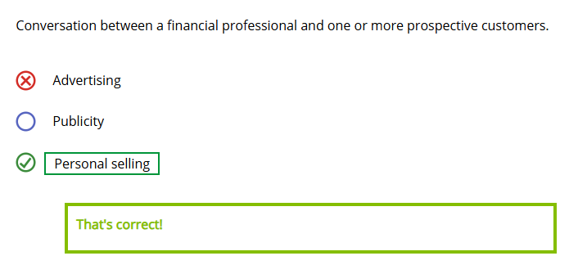
True or false?

Institutional advertising is intended to present the details of a specific product.
- True
- False
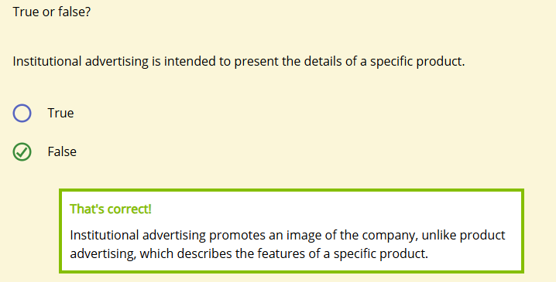
When an insurer ensures that customers can learn about and purchase its products in the ways that best meet their needs and preferences, which of the Four Cs is the insurer addressing?
- Customer
- Cost
- Convenience
- Communication
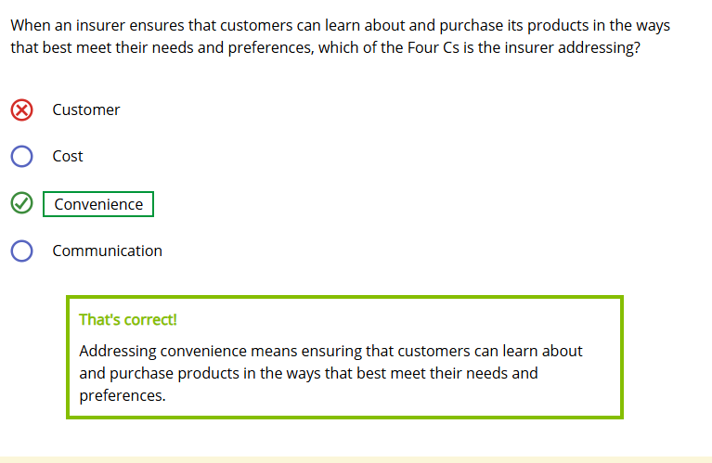
When a company uses the marketing mix to create a unique market identity in the customer's mind, the company is engaging in
- Segmentation
- Positioning
- Mixing
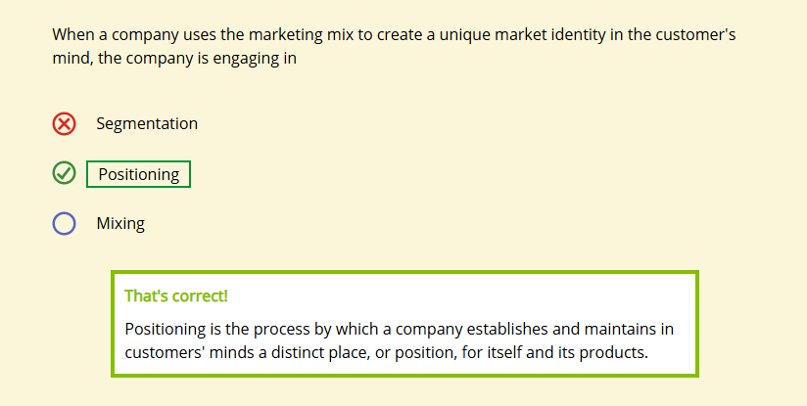

Target Marketing
Learning Objective
Describe how insurers use market segmentation and target marketing to identify the customers most likely to benefit from their products.
Distinguish among three primary types of target marketing strategies.
Knowing about the marketing mix is a good start, but there's a lot more to marketing. For example, how does a company choose its customer base?
Companies target individuals who have needs the company can feasibly meet. They consider how turning these people into customers can contribute to the company's earnings, growth, and overall financial strength.
Market Segmentation
We know we can't meet the needs of every customer in a profitable way—no financial services company can—so we need to decide who our target customers are. First, we divide the total market into a series of smaller submarkets with unique sets of needs. This process is called market segmentation.
A simple form of market segmentation is to divide the total market for insurance products into two categories:
- The consumer market
- The organizational market

I can see how that would narrow things down some, but isn't a segment made up of "individuals" still a little too big?

Below are two possible market segments for a new life insurance product.
- Segment A: Women between the ages of 35 and 45.
- Segment B: Divorced, single mothers between 35 and 45 years old who earn between $50,000 and $75,000 a year.
Which of these segments includes more potential customers?
- Segment A
- Segment B
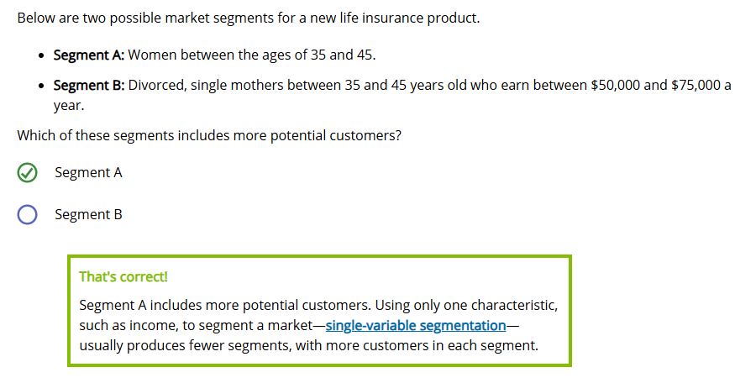
Now, which of the segments described above provides more detailed information to use in developing an effective, meaningful marketing mix?
- Segment A
- Segment B

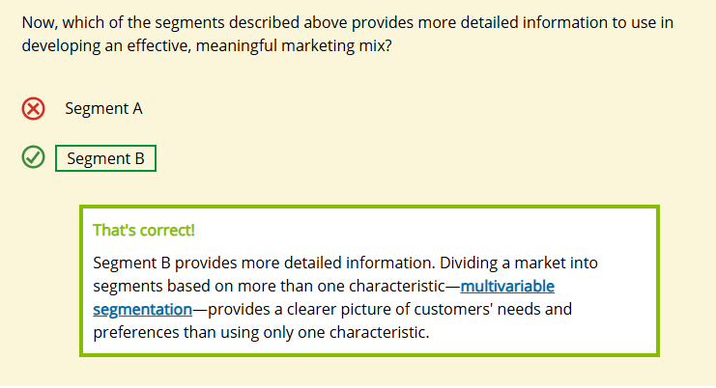
Target Marketing
Evaluating and selecting specific market segments to determine which are the most attractive is called target marketing. Companies usually select a target market based on such factors as
- Size
- Growth potential
- Distribution and service costs
- Current and expected competition
- Fit with the company's overall objectives and position
The number of market segments a company chooses depends on the target marketing strategy the company uses. Three options are undifferentiated marketing, concentrated marketing, and differentiated marketing.
Do you think you can recognize each approach from its name?

An insurer offers only mortgage protection life insurance policies for new homeowners.

Which approach is this insurer using?
- Undifferentiated marketing
- Concentrated marketing
- Differentiated marketing
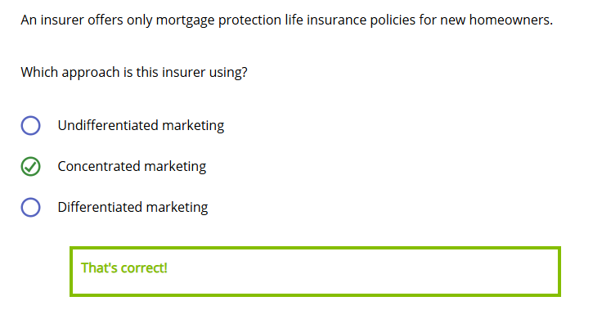

Here is an illustration of concentrated marketing.
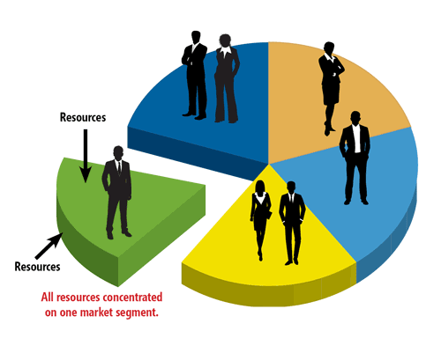

An insurer offers traditional whole life, universal life, and term life products to different segments, using a different marketing mix for each product.

Which approach is this insurer using?
- Undifferentiated marketing
- Concentrated marketing
- Differentiated marketing

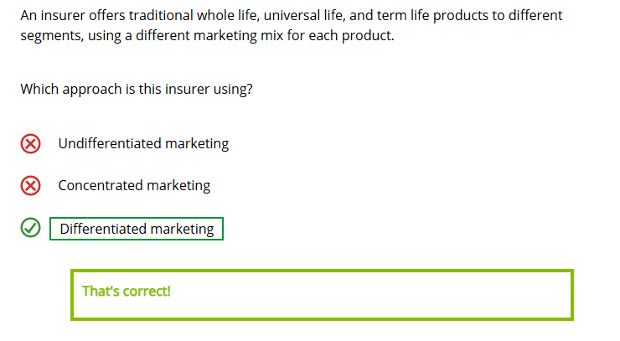

Here is an illustration of differentiated marketing.
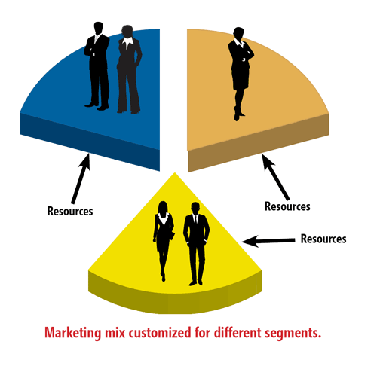

An insurer markets its small face amount term life insurance product to all potential life insurance customers, without distinguishing among segments of that market. It uses the same distribution channels, pricing structures, and promotions for all customers.

Which approach is this insurer using?
- Undifferentiated marketing
- Concentrated marketing
- Differentiated marketing
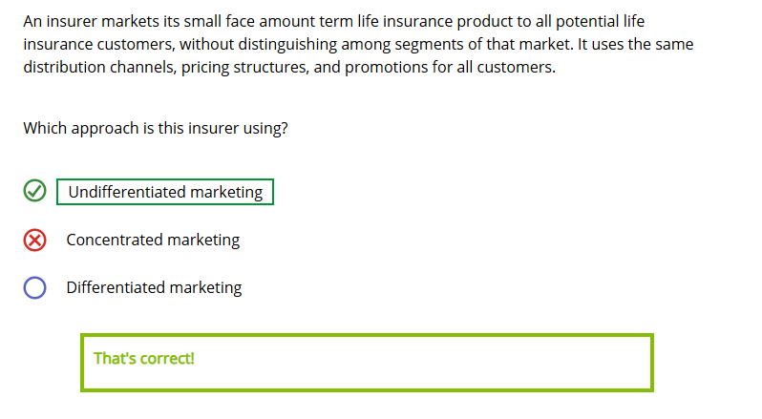

Here is an illustration of undifferentiated marketing.
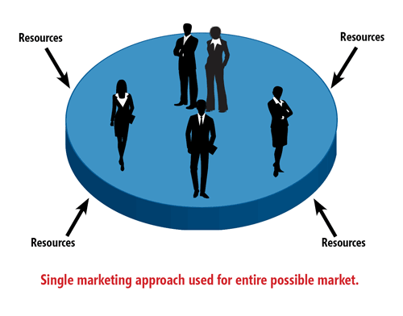

Below are characteristics of different target marketing strategies. Select each characteristic you think is a benefit of the strategy. You can choose more than one answer.

Following an undifferentiated marketing strategy allows insurers to (choose all that apply)
- Realize cost savings
- Lower product prices
- Better satisfy customers

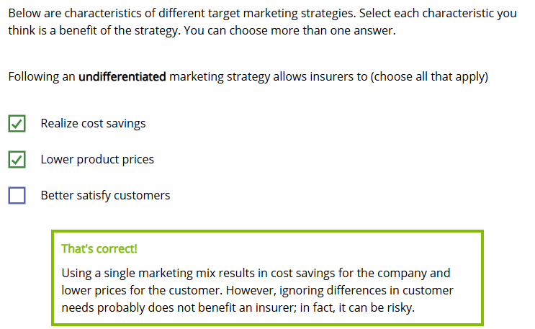
Following a concentrated marketing strategy allows insurers to (choose all that apply)
- Compete effectively with limited resources
- Reduce the company's product risk
- Develop expertise in a single market segment
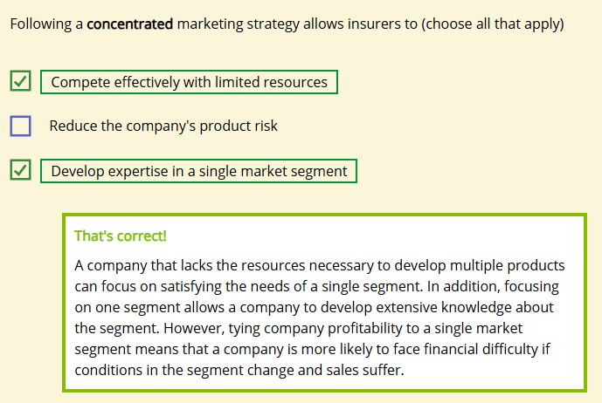
Following a differentiated marketing strategy allows insurers to
- Realize substantial cost savings from the creation of multiple products
- Diversify product risks
- Better satisfy the needs of customers
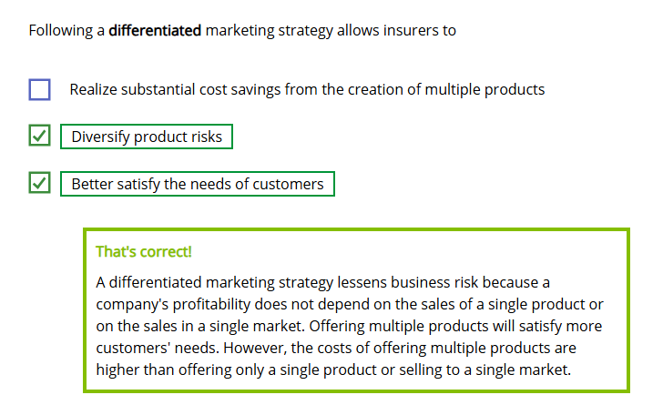


EndiFirst Insurance needs to limit marketing costs for its new product, but it believes the product should appeal to many different types of customers. EndiFirst should consider using a(n)
- Undifferentiated marketing strategy
- Concentrated marketing strategy
- Differentiated marketing strategy
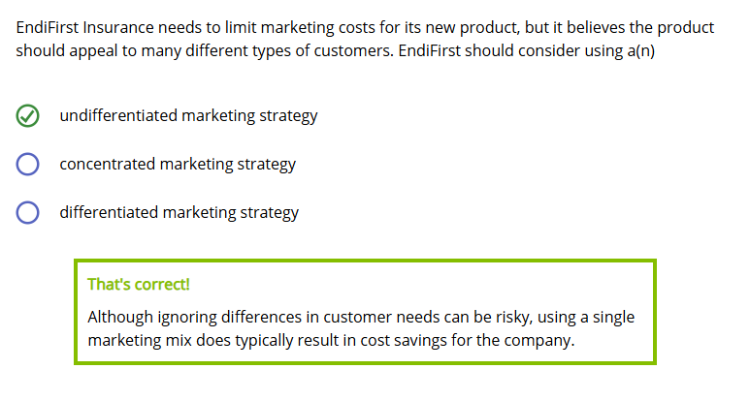
Raylite is trying to market its simplified issue product to millennial new parents. At the same time, Raylite wants to market its long-term care insurance to long-time customers who have existing life insurance policies. Raylite should use a(n)
- Undifferentiated marketing strategy
- Concentrated marketing strategy
- Differentiated marketing strategy
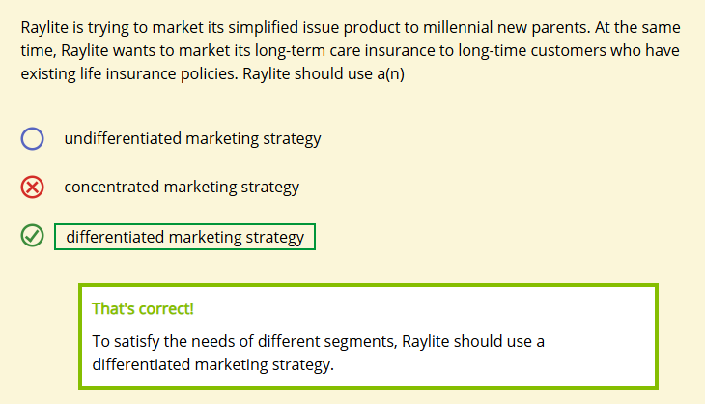

Marketing Information
Learning Objective
Describe different sources that insurers use for obtaining market information.
Identify elements in the internal and external marketing environments.
So, how does a company decide what market segments it will focus on?
To help it make this type of decision, a company collects information about several things: the market segment, itself, its competitors, the economy, regulations, and customers. Information about all of these is at the heart of making effective marketing decisions.
Let's take a look at the sources of this information.
Sources of Marketing Information
Click or touch each heading below to learn about sources of marketing information.
Internal Databases
Internal databases contain internal records and reports from throughout the company. These reports provide detailed information about a company's sales, expenses, profitability, products, promotions, distribution, customers, and markets.
Website and Social Media Analysis
Insurers can gain important insight into customer needs, interests, and attitudes by analyzing data about customer behavior on the company's website and on social media. Insurers may collect clickstream data to gain insight into how to best meet customer product needs or improve the customer experience. Many companies also pay attention to what customers and others say about the company or its products on social media, blogs, and online forums.
Competitive and Market Intelligence
Insurers need information, often called competitive intelligence, about their competitors. Specifically, insurers want to know about their competitors' marketing mixes, target markets, service quality, market shares, marketing strategies, and product mixes.
In addition, insurers need information about ongoing developments in the marketing environment, often called market intelligence. Specifically, insurers want to identify issues that might impact a market's potential. Insurers obtain most of their competitive and market information from publicly available sources, like company websites or financial services publications.

Marketing Research
Through marketing research, an insurer or independent company collects, interprets, and reports information related to specific marketing problems or opportunities. It provides information about customers, products, and distribution channels on an as-needed or one-time basis.
The Marketing Environment
Insurers analyze marketing information within the context of the company's current marketing environment. The marketing environment consists of all of the elements in the company's internal and external environments that affect the company's ability to carry out its marketing activities.
- A company's internal environment consists of elements within the company's control, such as financial, physical, technological, and human resources; organizational structure; and the marketing mix.
- A company's external environment consists of elements outside the company's control, such as economic, competitive, regulatory, taxation, and social factors.

Examples of the types of information Forthright uses for marketing are listed below. Read each example and determine which answer choice is the most likely source of each piece of information.
Customers in Forthright's market have responded to surveys indicating that adding guarantees to variable annuities makes them more attractive than other investment products.
- Internal database
- Marketing research
- Competitive and marketing intelligence
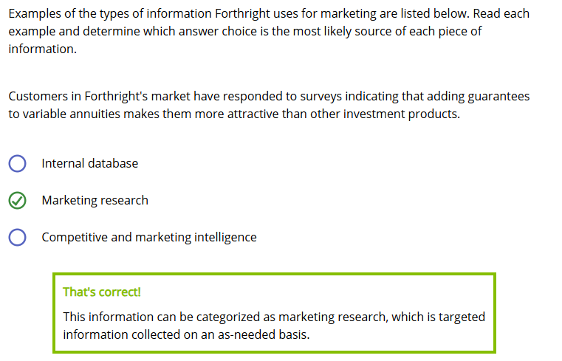
Forthright has maintained a 5% average profit margin on its annuity products over the past 5 years.
- Internal database
- Marketing research
- Competitive and marketing intelligence

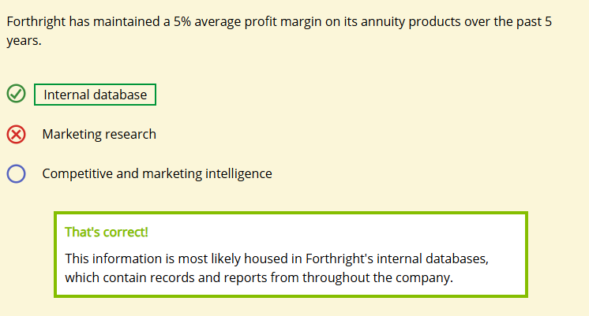
None of Forthright's competitors offers the same terms on its living benefit guarantees as Forthright's new product offers.
- Internal database
- Marketing research
- Competitive and marketing intelligence

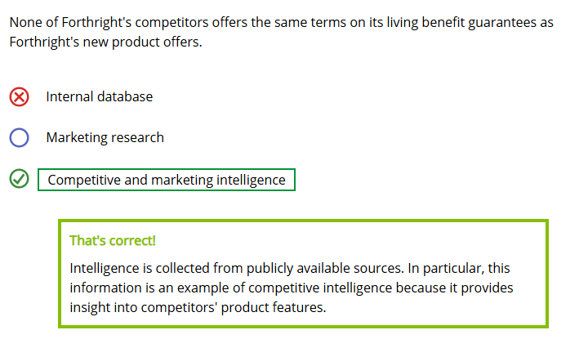

Marketing Responsibilities and Controls
Learning Objective
Explain the duties of the marketing department and what other functional areas contribute to marketing activities.
Describe marketing controls.


One last thing: Sometimes I see Damon from the Actuarial Department meeting with Beth from Marketing. What are they talking about?

Responsibilities of the Marketing Department
The Marketing department handles some of the work we have discussed, exclusively or at least primarily:
- Advertising
- Obtaining marketing information
- Segmenting markets
- Target marketing
However, the Marketing department also makes valuable contributions to other activities we've mentioned. Click or touch each heading below for more information about these activities.
Developing Strategy
Executive management gets input from Marketing when developing the overall marketing strategy.
Product Development
Actuaries and other departments get input from Marketing when developing products.
Product Financial Design
Actuaries get input from Marketing when working on a product's financial design.
Distribution
Departments handling sales and distribution typically have close ties with Marketing.
Corporate Communications
The corporate communications department generally handles news releases, but they may collaborate with Marketing to ensure a cohesive brand.
Marketing Controls
Marketing managers need a way to measure whether they are achieving the goals set out in the marketing plan. For example, did sales of indexed annuities increase as a result of an advertisement targeted to high net worth individuals?
Companies typically state performance standards in the marketing plan goals, and gauge whether they achieve their goals by comparing actual performance with the standard. Here are some tools insurers use to measure marketing performance. Use the arrows to navigate.

Sales Analysis
Using sales analysis, a company examines its sales numbers to evaluate current performance. Current actual sales are often compared to forecasted sales, sales in previous years, competitors' sales, or other performance standards.
If a performance does not match the standard, the insurer investigates to determine the reasons for the discrepancy, and adjusts accordingly. Examples of adjustments that may need to be made include
- Changing tactical/action programs or implementation strategies
- Developing more precise methods of collecting or analyzing performance data if the current way does not reflect true performance
- Reviewing performance standards to ensure that they are realistic
- Developing new products, new marketing strategies, or new marketing goals

Select the functions for which each area has primary responsibility. More than one response may be correct.

Marketing area
- Market research
- Advertising
- Product financial design
- News releases
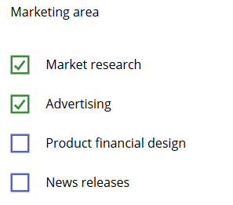
Corporate communications area
- Market research
- Advertising
- Product financial design
- News releases
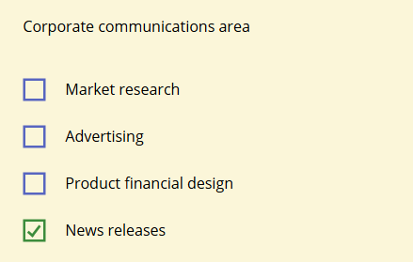
Actuarial area
- Market research
- Advertising
- Product financial design
- News releases
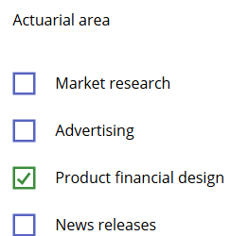

The process of determining which costs are associated with particular activities to help managers decide if a cost is worth the value the activity provides is called
- Sales analysis
- Expense analysis
- Profitability analysis

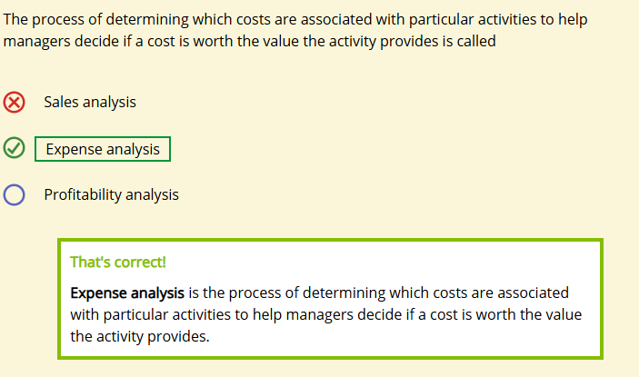
Examples of possible adjustments that may need to be made if marketing goals are not met include (choose all that apply)
- Changing tactical/action programs or implementation strategies
- Developing less precise measures of collecting or analyzing performance data
- Reviewing performance standards to ensure that they are realistic
- Developing new products, new marketing strategies, or new marketing goals
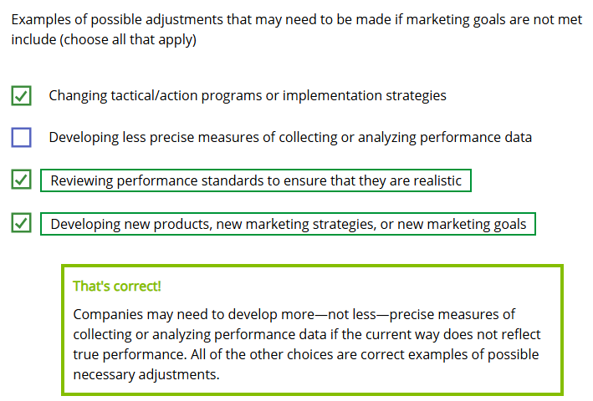

Examples of possible adjustments that may need to be made if marketing goals are not met include (choose all that apply)

